Directory structure

----Inc

-configLoader.h

-ThreadSafeLogger.h

----Src

-configLoader.cpp

-ThreadSafeLogger.cpp

----Others

-conf.properties

------------------------------------------------------------------------------------------------------------------------------------------------------

Log file is format will be DDMMYYYY.log. This will be computed with the help of ctime library.

Timestamp code is also written using ctime library

------------------------------------------------------------------------------------------------------------------------------------------------------

Logging is based on configuration (conf.properties -> hardcoded file name inside code)

isFileBasedLog = 0 means console based logging

isFileBasedLog = 1 means file based logging

------------------------------------------------------------------------------------------------------------------------------------------------------

1]configured - file based logs

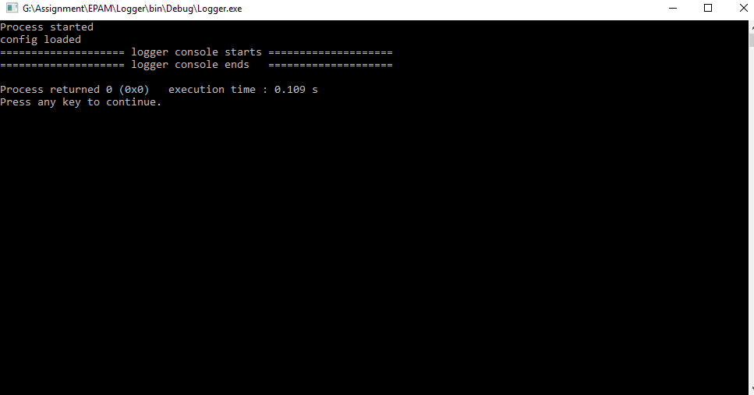

1]configured - console based logs

